Civil war in Georgia

UNSC Resolution: | 1494
Date of adoption: | 07/30/03
Operative paragraph: | 5
Demand number: | 1494.0511

David Siroky

Wording of demand

receive the "Basic Principles for the Distribution of Competencies between Tbilisi and Sukhumi" and its transmittal letter

List of addressees of the demand

Government of Georgia, Abkhazia

Short-term compliance

Description of the addressee(s)’ conduct

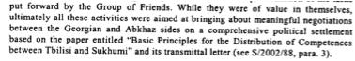

S/2003/1019

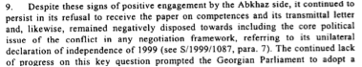

S/2003/1019

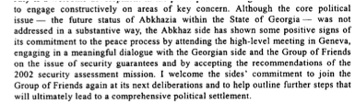
S/2003/1019

Assessment

Short-term compliance
No or marginal compliance (1) | Medium low compliance (2) | Medium high compliance (3) | Full or almost full compliance (4)

Considerations underlying the assessment

Medium-term compliance

Description of the addressee(s)’ conduct

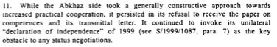

S/2004/26

Assessment

Medium-term compliance
No or marginal compliance (1) | Medium low compliance (2) | Medium high compliance (3) | Full or almost full compliance (4)

Considerations underlying the assessment

Depth of demand

Assessment

Level of depth of demand
Low depth of demand (1) | Medium depth of demand (2) | High depth of demand (3)

Considerations underlying the assessment

Level of confidence about coding decisions

Level of confidence about coding decision
Extremely high | High | Moderate

Comments to IPI (if any)

Civil war in Georgia

UNSC Resolution: | 1494
Date of adoption: | 07/30/03
Operative paragraph: | 5
Demand number: | 1494.0512

David Siroky

Wording of demand

give "Basic Principles for the Distribution of Competencies between Tbilisi and Sukhumi" full and open consideration and engage in constructive negotiations on their substance

List of addressees of the demand

Government of Georgia, Abkhazia

Short-term compliance

Description of the addressee(s)’ conduct

S/2003/1019

S/2003/1019

S/2003/1019

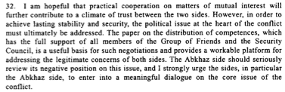
S/2003/1019

Assessment

Short-term compliance
No or marginal compliance (1) | Medium low compliance (2) | Medium high compliance (3) | Full or almost full compliance (4)

Considerations underlying the assessment

Medium-term compliance

Description of the addressee(s)’ conduct

S/2004/26

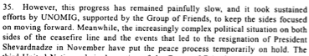
S/2004/26

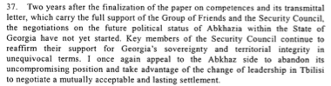
S/2004/26

Assessment

Medium-term compliance
No or marginal compliance (1) | Medium low compliance (2) | Medium high compliance (3) | Full or almost full compliance (4)

Considerations underlying the assessment

Depth of demand

Assessment

Level of depth of demand
Low depth of demand (1) | Medium depth of demand (2) | High depth of demand (3)

Considerations underlying the assessment

Level of confidence about coding decisions

Level of confidence about coding decision
Extremely high | High | Moderate

Comments to IPI (if any)

Civil war in Georgia

UNSC Resolution: | 1494
Date of adoption: | 07/30/03
Operative paragraph: | 11
Demand number: | 1494.1111

David Siroky

Wording of demand

spare no efforts to overcome ongoing mutual mistrust of the other party

List of addressees of the demand

Government of Georgia, Abkhazia

Short-term compliance

Description of the addressee(s)’ conduct

S/2003/1019

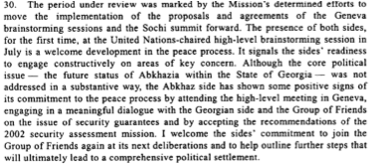
S/2003/1019

Assessment

Short-term compliance
No or marginal compliance (1) | Medium low compliance (2) | Medium high compliance (3) | Full or almost full compliance (4)

Considerations underlying the assessment

Medium-term compliance

Description of the addressee(s)’ conduct

S/2004/26

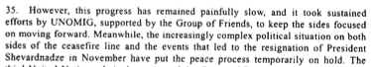
S/2004/26

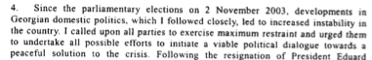
S/2004/26

Assessment

Medium-term compliance
No or marginal compliance (1) | Medium low compliance (2) | Medium high compliance (3) | Full or almost full compliance (4)

Considerations underlying the assessment

Depth of demand

Assessment

Level of depth of demand
Low depth of demand (1) | Medium depth of demand (2) | High depth of demand (3)

Considerations underlying the assessment

Level of confidence about coding decisions

Level of confidence about coding decision
Extremely high | High | Moderate

Comments to IPI (if any)

Civil war in Georgia

UNSC Resolution: | 1494
Date of adoption: | 07/30/03
Operative paragraph: | 12
Demand number: | 1494.1211

David Siroky

Wording of demand

ensure the necessary revitalization of the peace process in all its major aspects, to resume work in the Coordinating council and its relevant mechanisms, to build on the results of the Yalta meeting on confidence-building measures, and to implement the proposals agreed on that occasion in a purposeful and cooperative manner, and to consider holding a fourth conference on confidence-building measures

List of addressees of the demand

Government of Georgia, Abkhazia

Short-term compliance

Description of the addressee(s)’ conduct

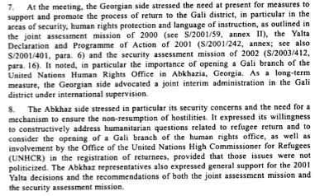
S/2003/1019

Assessment

Short-term compliance
No or marginal compliance (1) | Medium low compliance (2) | Medium high compliance (3) | Full or almost full compliance (4)

Considerations underlying the assessment

Medium-term compliance

Description of the addressee(s)’ conduct

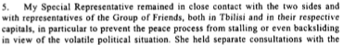
S/2004/26

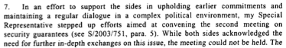

S/2004/26

Assessment

Medium-term compliance
No or marginal compliance (1) | Medium low compliance (2) | Medium high compliance (3) | Full or almost full compliance (4)

Considerations underlying the assessment

Depth of demand

Assessment

Level of depth of demand
Low depth of demand (1) | Medium depth of demand (2) | High depth of demand (3)

Considerations underlying the assessment

Level of confidence about coding decisions

Level of confidence about coding decision
Extremely high | High | Moderate

Comments to IPI (if any)

Civil war in Georgia

UNSC Resolution: | 1494
Date of adoption: | 07/30/03
Operative paragraph: | 13
Demand number: | 1494.1311

David Siroky

Wording of demand

refrain from any action that might impede the peace process

List of addressees of the demand

Government of Georgia, Abkhazia

Short-term compliance

Description of the addressee(s)’ conduct

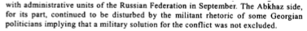
S/2003/1019

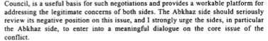
S/2003/1019

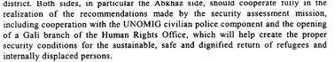
S/2003/1019

Assessment

Short-term compliance
No or marginal compliance (1) | Medium low compliance (2) | Medium high compliance (3) | Full or almost full compliance (4)

Considerations underlying the assessment

Medium-term compliance

Description of the addressee(s)’ conduct

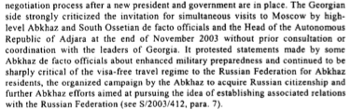

S/2004/26

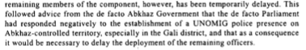
S/2004/26

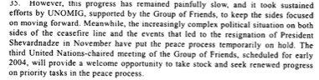
S/2004/26

Assessment

Medium-term compliance
No or marginal compliance (1) | Medium low compliance (2) | Medium high compliance (3) | Full or almost full compliance (4)

Considerations underlying the assessment

Depth of demand

Assessment

Level of depth of demand
Low depth of demand (1) | Medium depth of demand (2) | High depth of demand (3)

Considerations underlying the assessment

Level of confidence about coding decisions

Level of confidence about coding decision
Extremely high | High | Moderate

Comments to IPI (if any)

Civil war in Georgia

UNSC Resolution: | 1494
Date of adoption: | 07/30/03
Operative paragraph: | 15
Demand number: | 1494.1511

David Siroky

Wording of demand

protect returning refugees and displaced persons and facilitate the return of the reamining displaced population

List of addressees of the demand

Government of Georgia, Abkhazia

Short-term compliance

Description of the addressee(s)’ conduct

S/2003/1019

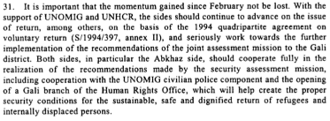

S/2003/1019

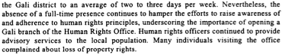

S/2003/1019

Assessment

Short-term compliance
No or marginal compliance (1) | Medium low compliance (2) | Medium high compliance (3) | Full or almost full compliance (4)

Considerations underlying the assessment

Medium-term compliance

Description of the addressee(s)’ conduct

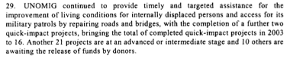
S/2004/26

S/2004/26

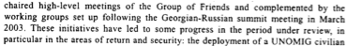
S/2004/26

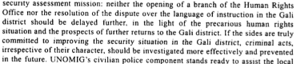
S/2004/26

Assessment

Medium-term compliance
No or marginal compliance (1) | Medium low compliance (2) | Medium high compliance (3) | Full or almost full compliance (4)

Considerations underlying the assessment

Depth of demand

Assessment

Level of depth of demand
Low depth of demand (1) | Medium depth of demand (2) | High depth of demand (3)

Considerations underlying the assessment

Level of confidence about coding decisions

Level of confidence about coding decision
Extremely high | High | Moderate

Comments to IPI (if any)

Civil war in Georgia

UNSC Resolution: | 1494
Date of adoption: | 07/30/03
Operative paragraph: | 16
Demand number: | 1494.1611

David Siroky

Wording of demand

implement recommendations of the joint assessment mission to the Gali District

List of addressees of the demand

Government of Georgia, Abkhazia

Short-term compliance

Description of the addressee(s)’ conduct

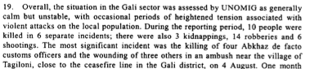
S/2003/1019

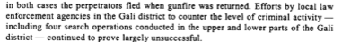
S/2003/1019

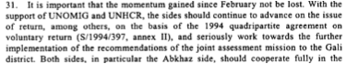

S/2003/1019

Assessment

Short-term compliance
No or marginal compliance (1) | Medium low compliance (2) | Medium high compliance (3) | Full or almost full compliance (4)

Considerations underlying the assessment

Medium-term compliance

Description of the addressee(s)’ conduct

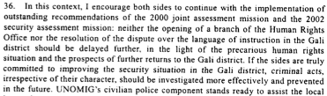
S/2004/26

S/2004/26

S/2004/26

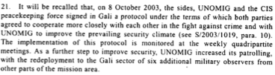
S/2004/26

Assessment

Medium-term compliance
No or marginal compliance (1) | Medium low compliance (2) | Medium high compliance (3) | Full or almost full compliance (4)

Considerations underlying the assessment

Depth of demand

Assessment

Level of depth of demand
Low depth of demand (1) | Medium depth of demand (2) | High depth of demand (3)

Considerations underlying the assessment

Level of confidence about coding decisions

Level of confidence about coding decision
Extremely high | High | Moderate

Comments to IPI (if any)

Civil war in Georgia

UNSC Resolution: | 1494
Date of adoption: | 07/30/03
Operative paragraph: | 16
Demand number: | 1494.1612

David Siroky

Wording of demand

agree to the opening as soon as possible of the Gali branch of the human rights office in Sukhumi and provide security conditions for its unhindered functioning

List of addressees of the demand

Government of Georgia, Abkhazia

Short-term compliance

Description of the addressee(s)’ conduct

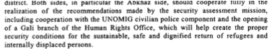
S/2003/1019

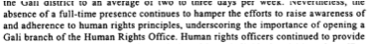
S/2003/1019

Assessment

Short-term compliance
No or marginal compliance (1) | Medium low compliance (2) | Medium high compliance (3) | Full or almost full compliance (4)

Considerations underlying the assessment

Medium-term compliance

Description of the addressee(s)’ conduct

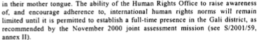
S/2004/26
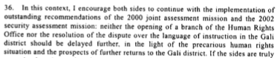
S/2004/26

Assessment

Medium-term compliance
No or marginal compliance (1) | Medium low compliance (2) | Medium high compliance (3) | Full or almost full compliance (4)

Considerations underlying the assessment

Depth of demand

Assessment

Level of depth of demand
Low depth of demand (1) | Medium depth of demand (2) | High depth of demand (3)

Considerations underlying the assessment

Level of confidence about coding decisions

Level of confidence about coding decision
Extremely high | High | Moderate

Comments to IPI (if any)

Civil war in Georgia

UNSC Resolution: | 1494
Date of adoption: | 07/30/03
Operative paragraph: | 18
Demand number: | 1494.1811

David Siroky

Wording of demand

improve law enforcement involving the local population and address the lack of instruction in Georgian of the local Georgian population

List of addressees of the demand

Government of Georgia, Abkhazia

Short-term compliance

Description of the addressee(s)’ conduct

S/2003/1019
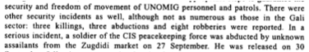

S/2003/1019

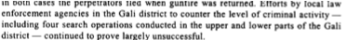
S/2003/1019

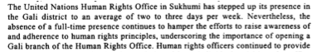
S/2003/1019

Assessment

Short-term compliance
No or marginal compliance (1) | Medium low compliance (2) | Medium high compliance (3) | Full or almost full compliance (4)

Considerations underlying the assessment

Medium-term compliance

Description of the addressee(s)’ conduct

S/2004/26

S/2004/26

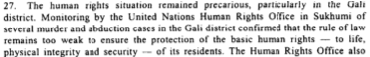
S/2004/26

Assessment

Medium-term compliance
No or marginal compliance (1) | Medium low compliance (2) | Medium high compliance (3) | Full or almost full compliance (4)

Considerations underlying the assessment

Depth of demand

Assessment

Level of depth of demand
Low depth of demand (1) | Medium depth of demand (2) | High depth of demand (3)

Considerations underlying the assessment

Level of confidence about coding decisions

Level of confidence about coding decision
Extremely high | High | Moderate

Comments to IPI (if any)

Civil war in Georgia

UNSC Resolution: | 1494
Date of adoption: | 07/30/03
Operative paragraph: | 20
Demand number: | 1494.2011

David Siroky

Wording of demand

dissociate from militant rhetoric and demonstrations of support for military options and for the activities of illegal armed groups

List of addressees of the demand

Government of Georgia, Abkhazia

Short-term compliance

Description of the addressee(s)’ conduct

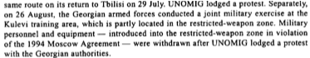

S/2003/1019

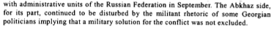
S/2003/1019

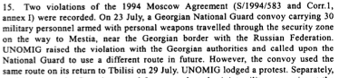
S/2003/1019

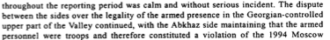
S/2003/1019

Assessment

Short-term compliance
No or marginal compliance (1) | Medium low compliance (2) | Medium high compliance (3) | Full or almost full compliance (4)

Considerations underlying the assessment

Medium-term compliance

Description of the addressee(s)’ conduct

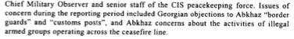
S/2004/26

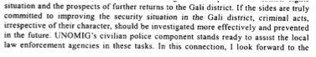
S/2004/26

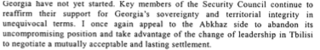
S/2004/26

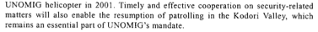
S/2004/26

Assessment

Medium-term compliance
No or marginal compliance (1) | Medium low compliance (2) | Medium high compliance (3) | Full or almost full compliance (4)

Considerations underlying the assessment

Depth of demand

Assessment

Level of depth of demand
Low depth of demand (1) | Medium depth of demand (2) | High depth of demand (3)

Considerations underlying the assessment

Level of confidence about coding decisions

Level of confidence about coding decision
Extremely high | High | Moderate

Comments to IPI (if any)

Civil war in Georgia

UNSC Resolution: | 1494
Date of adoption: | 07/30/03
Operative paragraph: | 20
Demand number: | 1494.2012

David Siroky

Wording of demand

continue efforts to put an end to the activities of illegal armed groups

List of addressees of the demand

Government of Georgia, Abkhazia

Short-term compliance

Description of the addressee(s)’ conduct

S/2003/1019

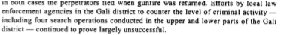
S/2003/1019

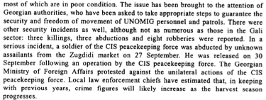
S/2003/1019

S/2003/1019

Assessment

Short-term compliance
No or marginal compliance (1) | Medium low compliance (2) | Medium high compliance (3) | Full or almost full compliance (4)

Considerations underlying the assessment

Medium-term compliance

Description of the addressee(s)’ conduct

S/2004/26
S/2004/26

Assessment

Medium-term compliance
No or marginal compliance (1) | Medium low compliance (2) | Medium high compliance (3) | Full or almost full compliance (4)

Considerations underlying the assessment

Depth of demand

Assessment

Level of depth of demand
Low depth of demand (1) | Medium depth of demand (2) | High depth of demand (3)

Considerations underlying the assessment

Level of confidence about coding decisions

Level of confidence about coding decision
Extremely high | High | Moderate

Comments to IPI (if any)

Civil war in Georgia

UNSC Resolution: | 1494
Date of adoption: | 07/30/03
Operative paragraph: | 21
Demand number: | 1494.2111

David Siroky

Wording of demand

continue to fully implement protocol signed on 2 April 2002 regarding the situation in the Kodori Valley (especially the Georgian party), observe security arrangements, and spare no efforts to agree to a mutually acceptable arrangement for security of the population in, and in the vicinity of, the Kodori Valley

List of addressees of the demand

Government of Georgia, Abkhazia

Short-term compliance

Description of the addressee(s)’ conduct

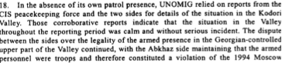

S/2003/1019

Assessment

Short-term compliance
No or marginal compliance (1) | Medium low compliance (2) | Medium high compliance (3) | Full or almost full compliance (4)

Considerations underlying the assessment

Medium-term compliance

Description of the addressee(s)’ conduct

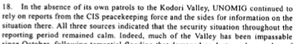

S/2004/26

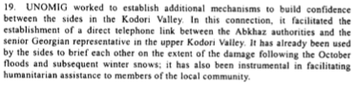
S/2004/26

Assessment

Medium-term compliance
No or marginal compliance (1) | Medium low compliance (2) | Medium high compliance (3) | Full or almost full compliance (4)

Considerations underlying the assessment

Depth of demand

Assessment

Level of depth of demand
Low depth of demand (1) | Medium depth of demand (2) | High depth of demand (3)

Considerations underlying the assessment

Level of confidence about coding decisions

Level of confidence about coding decision
Extremely high | High | Moderate

Comments to IPI (if any)

Civil war in Georgia

UNSC Resolution: | 1494
Date of adoption: | 07/30/03
Operative paragraph: | 23
Demand number: | 1494.2311

David Siroky

Wording of demand

take all necessary steps to identify those responsible for shooting down a UNOMIG helicopter on 8 October 2001 and bring them to justice, also informing the Special Representative on the implementation of these steps

List of addressees of the demand

Government of Georgia, Abkhazia

Short-term compliance

Description of the addressee(s)’ conduct

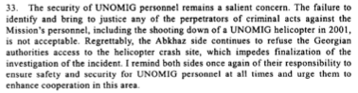

S/2003/1019

Assessment

Short-term compliance
No or marginal compliance (1) | Medium low compliance (2) | Medium high compliance (3) | Full or almost full compliance (4)

Considerations underlying the assessment

Medium-term compliance

Description of the addressee(s)’ conduct

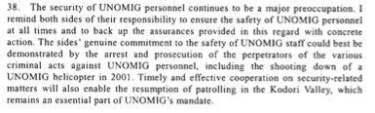

S/2004/26

Assessment

Medium-term compliance
No or marginal compliance (1) | Medium low compliance (2) | Medium high compliance (3) | Full or almost full compliance (4)

Considerations underlying the assessment

Depth of demand

Assessment

Level of depth of demand
Low depth of demand (1) | Medium depth of demand (2) | High depth of demand (3)

Considerations underlying the assessment

Level of confidence about coding decisions

Level of confidence about coding decision
Extremely high | High | Moderate

Comments to IPI (if any)

Civil war in Georgia

UNSC Resolution: | 1494
Date of adoption: | 07/30/03
Operative paragraph: | 24
Demand number: | 1494.2411

David Siroky

Wording of demand

continue to improve security for joint UNOMIG and CIS peacekeeping force patrols in the Kodori Valley to enable them to monitor the situation independently and regularly

List of addressees of the demand

Government of Georgia, Abkhazia

Short-term compliance

Description of the addressee(s)’ conduct

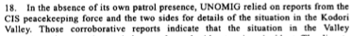
S/2003/1019

Assessment

Short-term compliance
No or marginal compliance (1) | Medium low compliance (2) | Medium high compliance (3) | Full or almost full compliance (4)

Considerations underlying the assessment

Medium-term compliance

Description of the addressee(s)’ conduct

S/2004/26

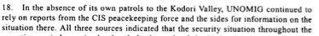

S/2004/26

Assessment

Medium-term compliance
No or marginal compliance (1) | Medium low compliance (2) | Medium high compliance (3) | Full or almost full compliance (4)

Considerations underlying the assessment

Depth of demand

Assessment

Level of depth of demand
Low depth of demand (1) | Medium depth of demand (2) | High depth of demand (3)

Considerations underlying the assessment

Level of confidence about coding decisions

Level of confidence about coding decision
Extremely high | High | Moderate

Comments to IPI (if any)

Civil war in Georgia

UNSC Resolution: | 1494
Date of adoption: | 07/30/03
Operative paragraph: | 25
Demand number: | 1494.2511

David Siroky

Wording of demand

provide appropriate security and ensure the freedom of movement of UNOMIG, the CIS peacekeeping force and other international personnel

List of addressees of the demand

Government of Georgia, Abkhazia

Short-term compliance

Description of the addressee(s)’ conduct

S/2003/1019

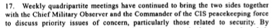
S/2003/1019

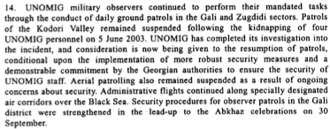
S/2003/1019

Assessment

Short-term compliance
No or marginal compliance (1) | Medium low compliance (2) | Medium high compliance (3) | Full or almost full compliance (4)

Considerations underlying the assessment

Medium-term compliance

Description of the addressee(s)’ conduct

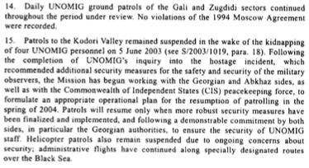

S/2004/26

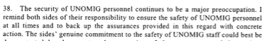
S/2004/26

Assessment

Medium-term compliance
No or marginal compliance (1) | Medium low compliance (2) | Medium high compliance (3) | Full or almost full compliance (4)

Considerations underlying the assessment

Depth of demand

Assessment

Level of depth of demand
Low depth of demand (1) | Medium depth of demand (2) | High depth of demand (3)

Considerations underlying the assessment

Level of confidence about coding decisions

Level of confidence about coding decision
Extremely high | High | Moderate

Comments to IPI (if any)

